Reopen option for Idoc cases

If you want to reopen any case in Idoc select reopen option.
Verification →Reopen

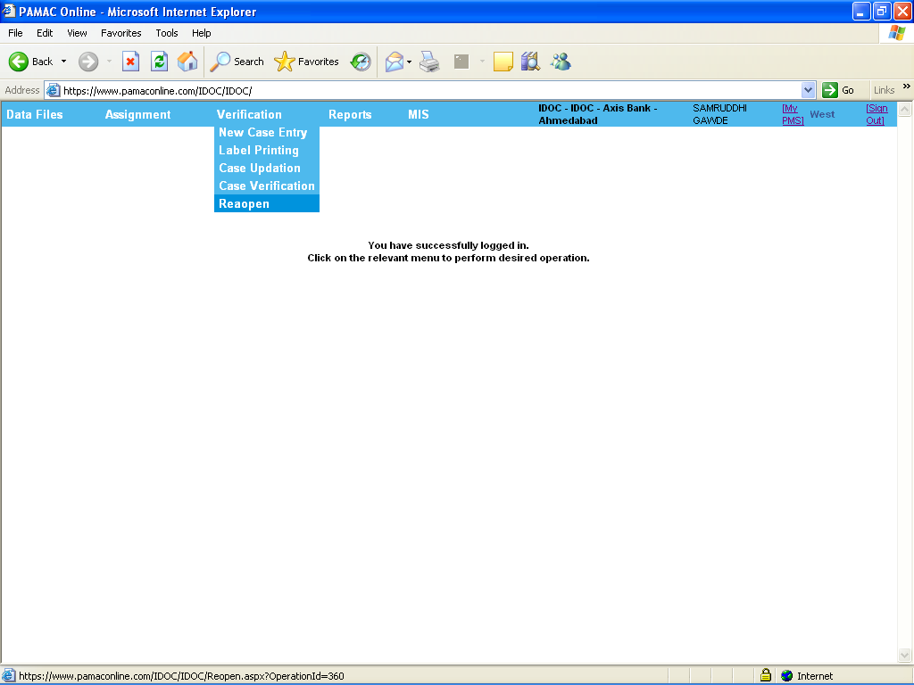

After clicking on Reopen option Reopen form is open

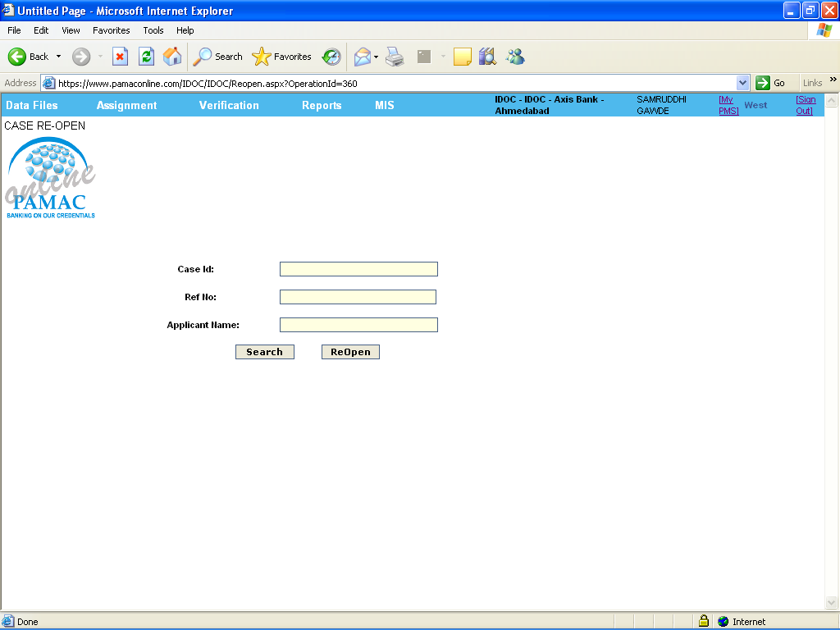

Insert the case id on text field and search related data like Ref No, Applicant Name by using search option (note: case Id * is mandatory field)

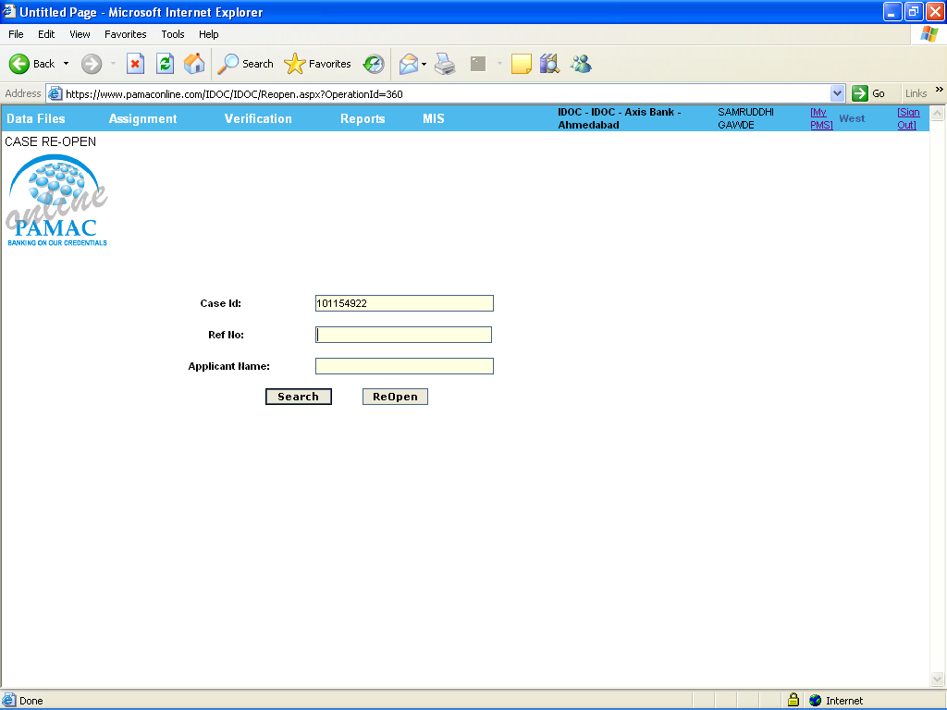

For reopen that search case use Reopen option

